# 01

Before your travel from your home country, you should notify your university of your travel itinerary. You should also make sure that you

have prepared the following documents:

# 02

Make your way to the EMGS International Student Arrival Centre (ISAC) as soon as you

03

Upon presenting the required documents, immigration will issue you with a Special Pass and you may proceed to collect your luggage



04

Once you’ve collected your luggage, you can find /book your



transportation to your hotel /

1.International Passport 2.Visa Approval Letter (VAL)

3. A Single-Entry Visa (SEV) (if required for your country)

4.Yellow fever vaccination certificate (if required for your country)

arrive at KLIA for any assistance.

from the carousel.

accommodation.

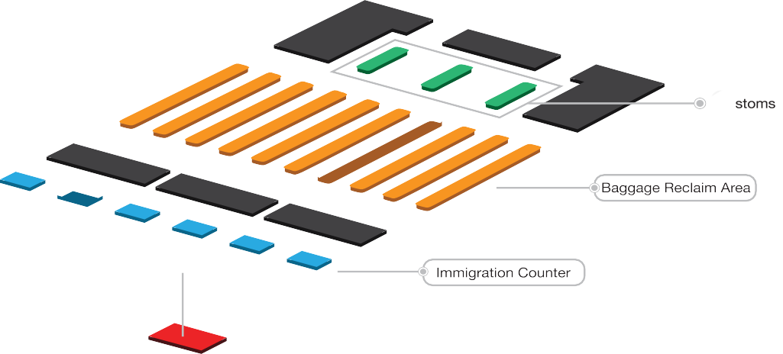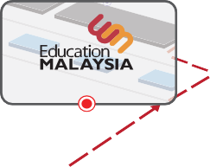

ISAC Counter

Escalator

Escalator

SELAMAT DATANG!

WELCOME TO MALAYSIA!

Remember:

* You are required to attend a medical screening within 7 days of your arrival at the EMGS panel clinic before you can receive your student pass to begin studying.
* After you have passed your medical screening, International Office (IO) will informed you to submit your passport for student pass endorsement by the Malaysian Immigration.
* Your i-Kad (Immigration Card) will be issued within 5 working days of your student pass endorsement in your passport.